ANSIBLE LAB 2

ADHOC COMMANDS

First login to your user

1. In ansible server

ansible demo -a “ls”

a => argument

demo => group

(this will list all the files in node1 and node2)

ansible demo -a “touch file1”

(it will create file1 in nodes)

ansible demo -a “sudo yum install httpd -y”

(this will install httpd in your nodes)

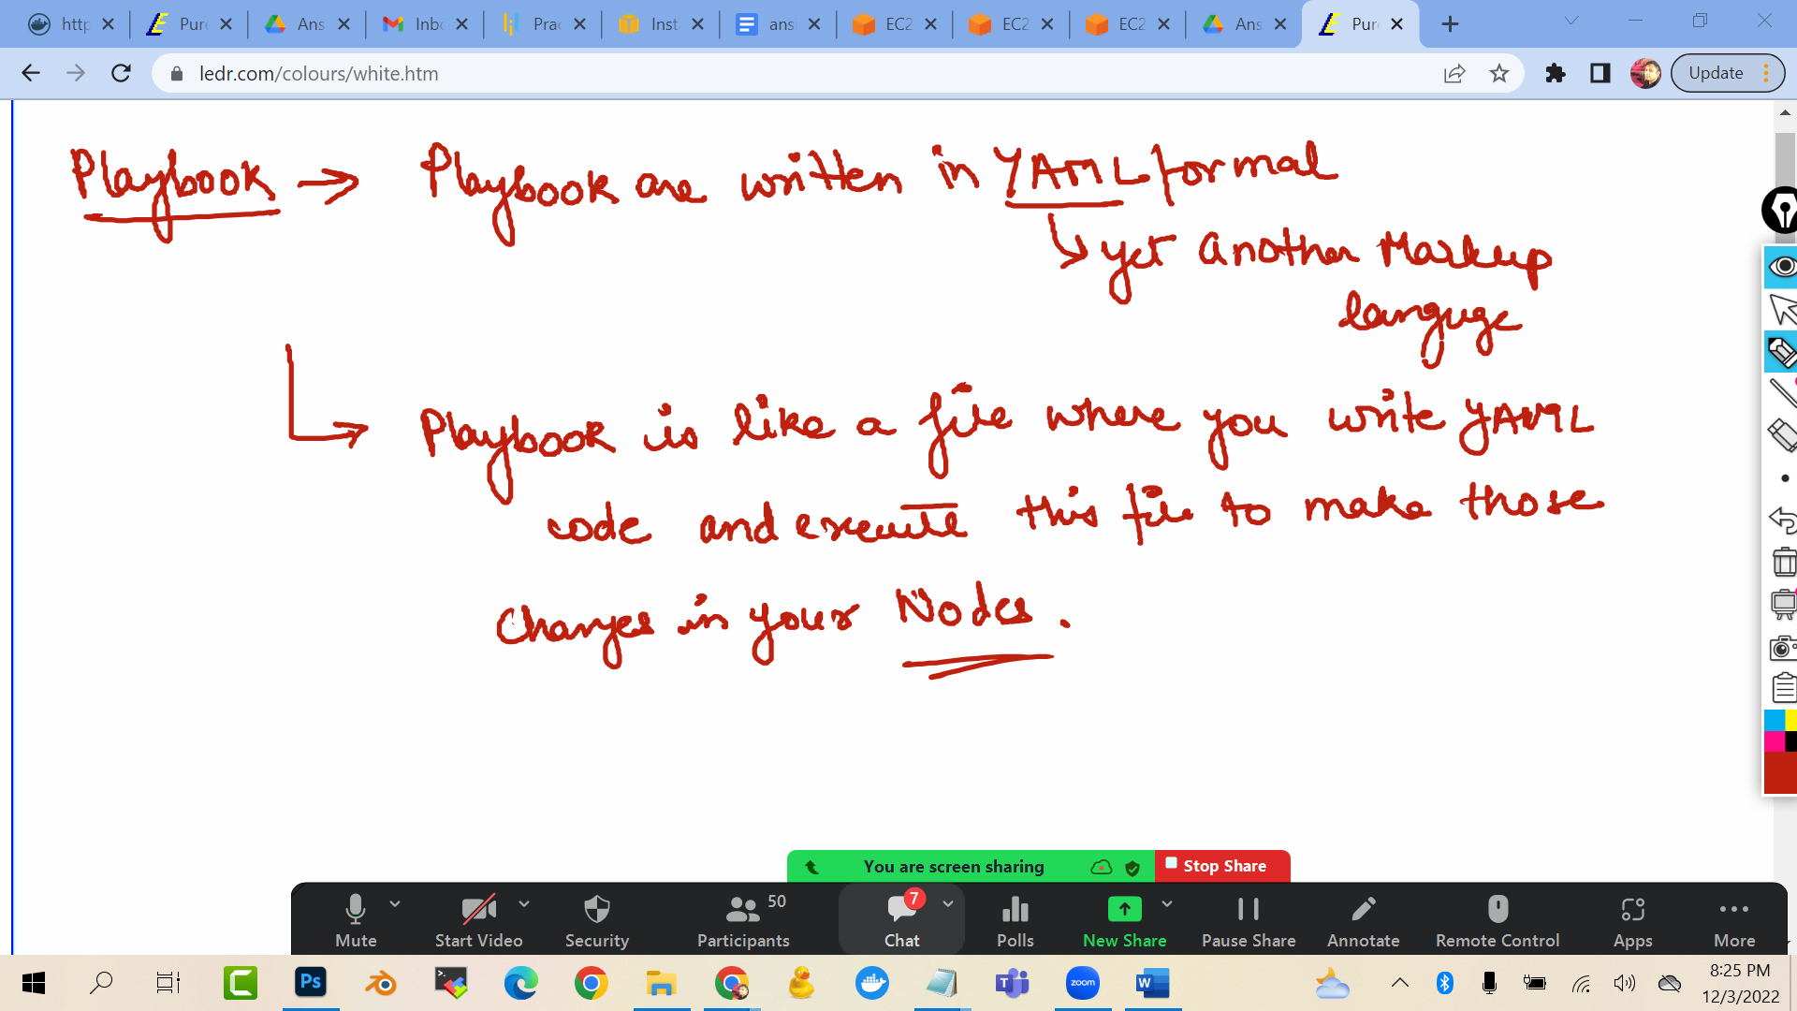

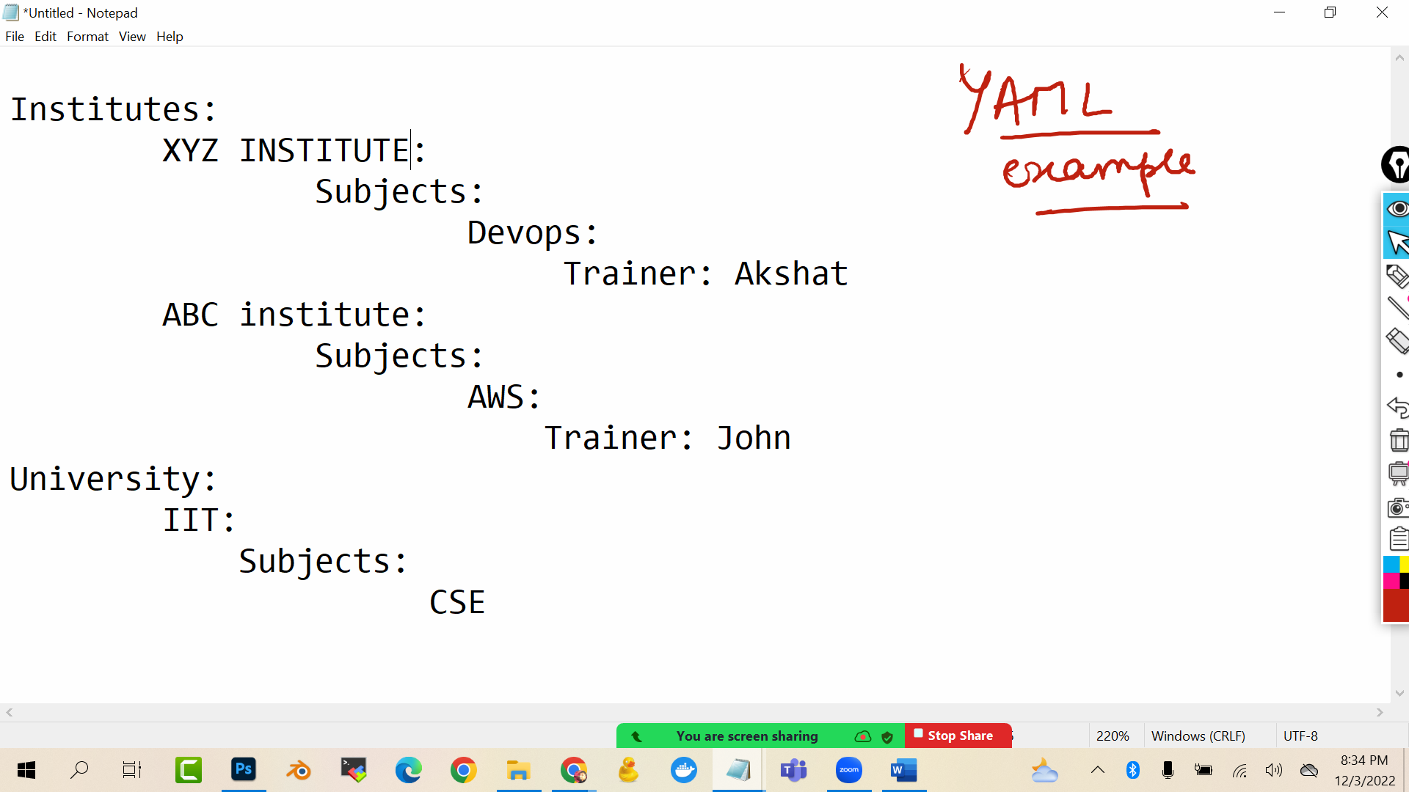

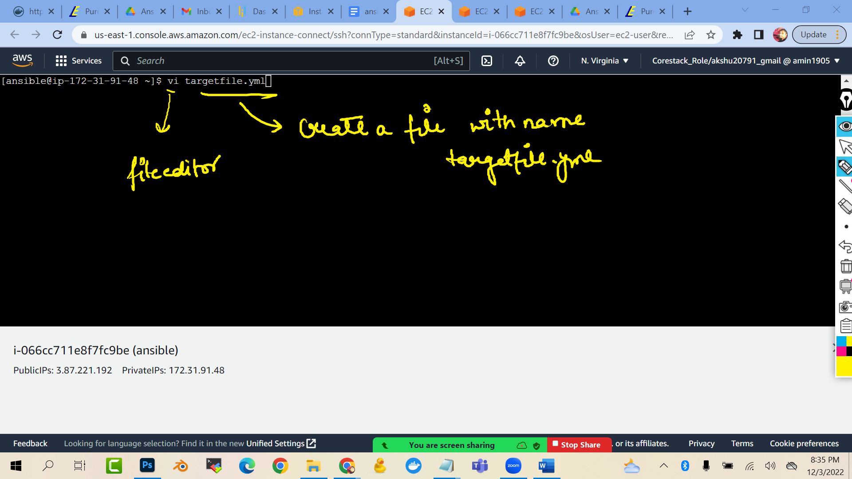

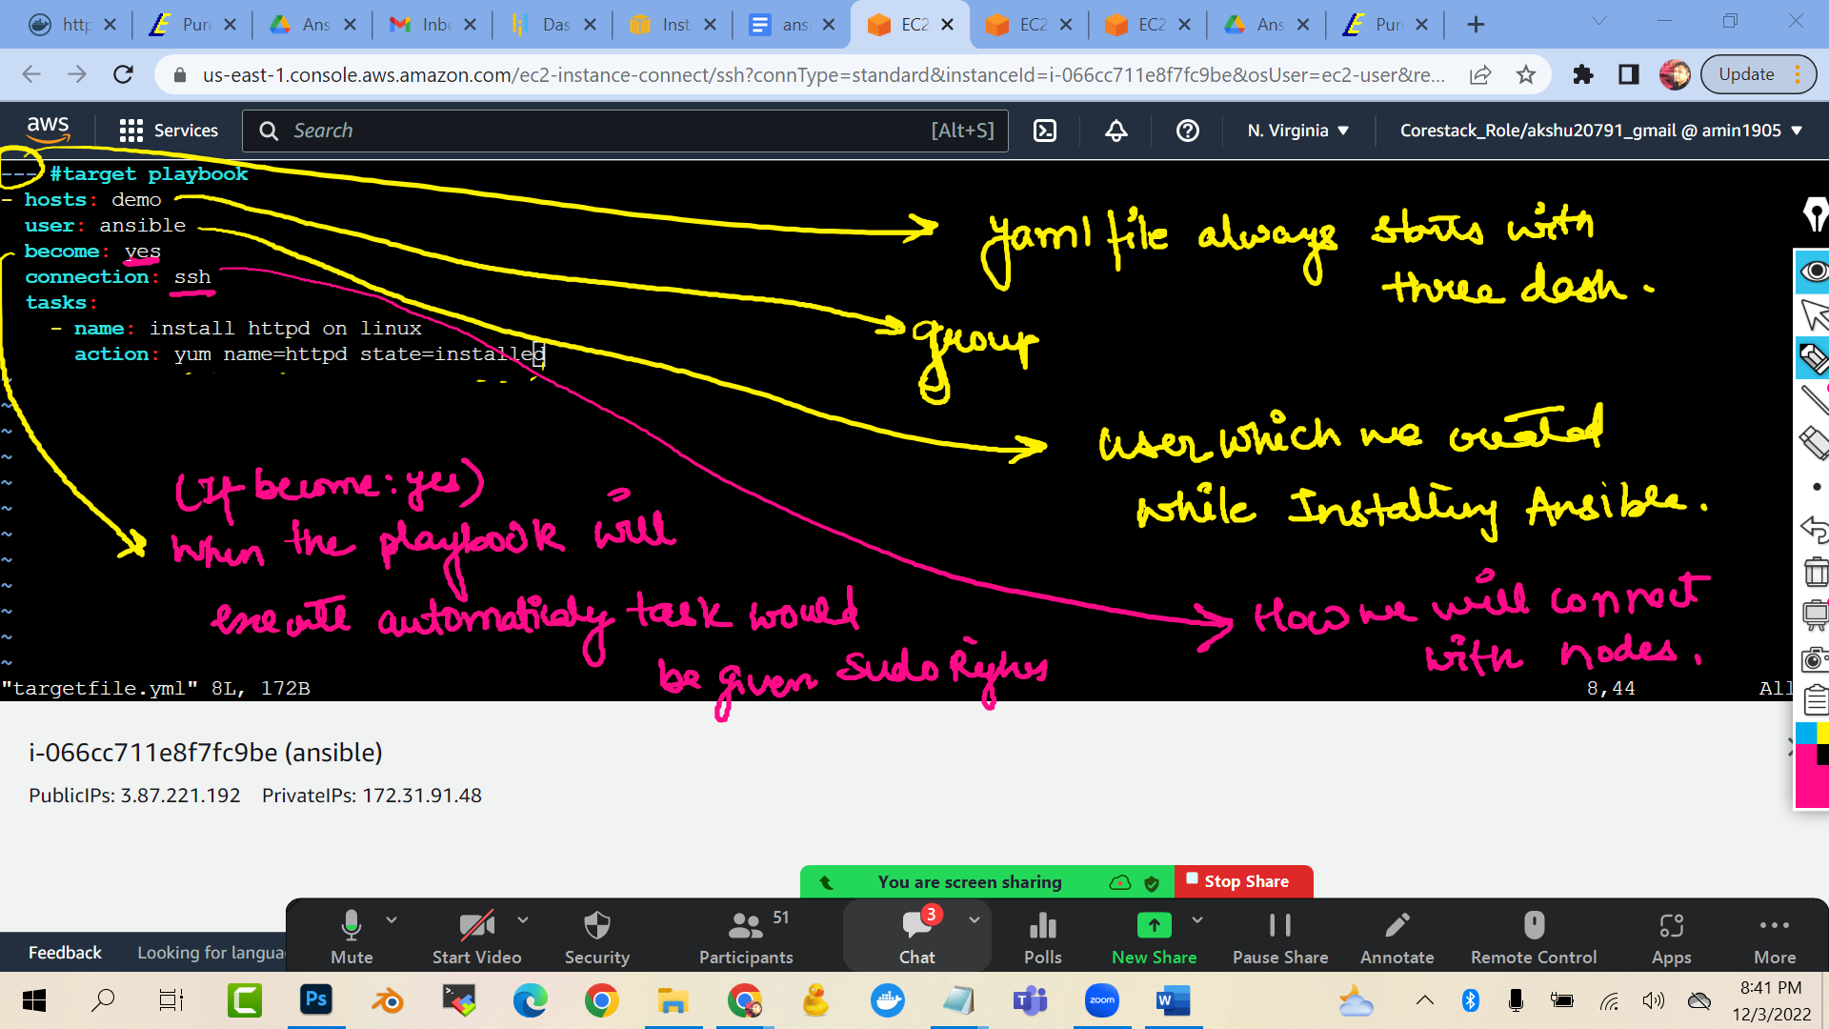

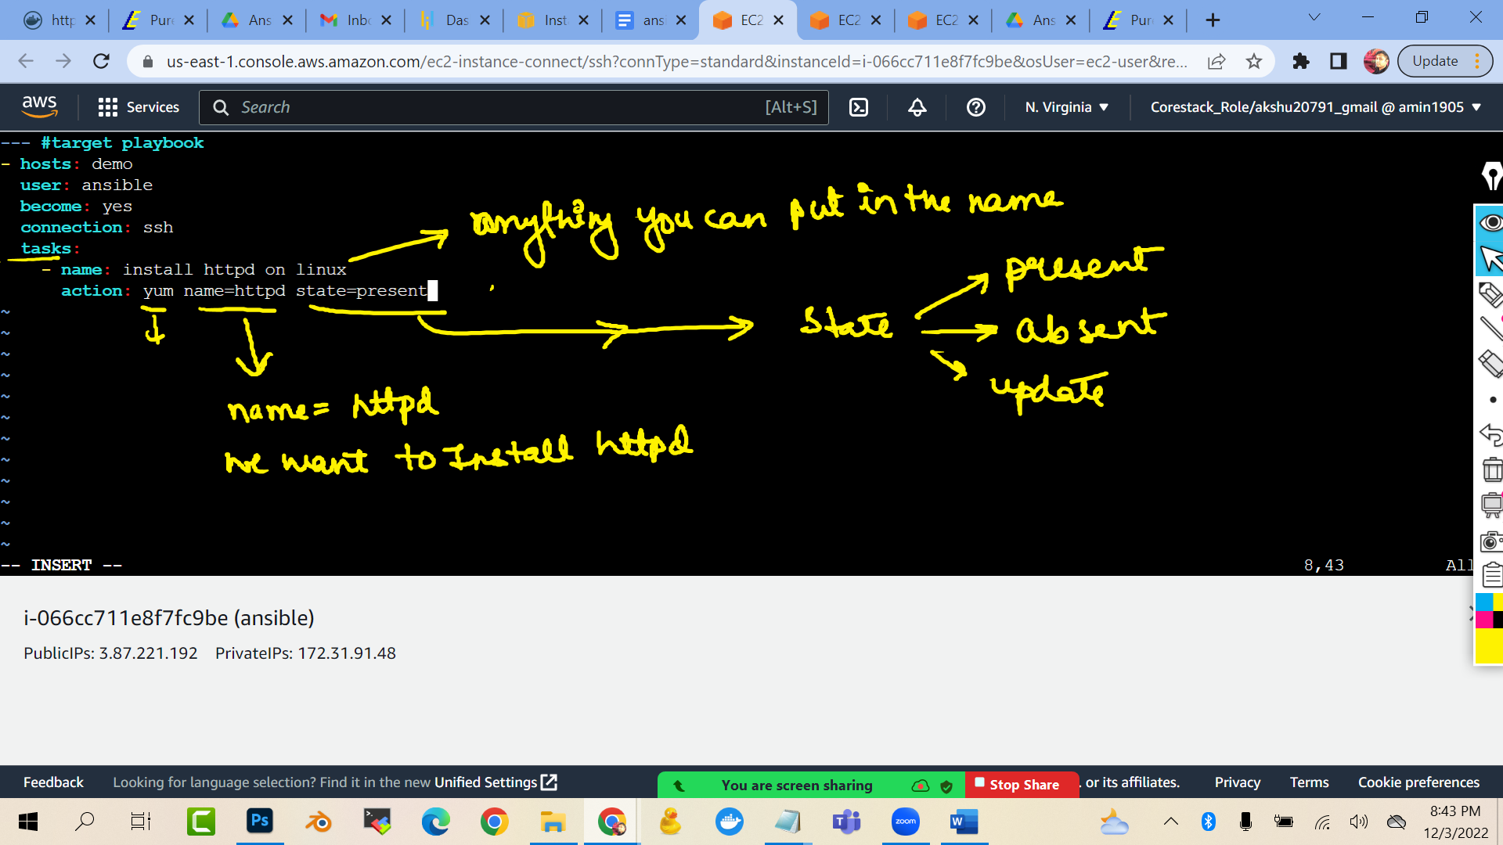

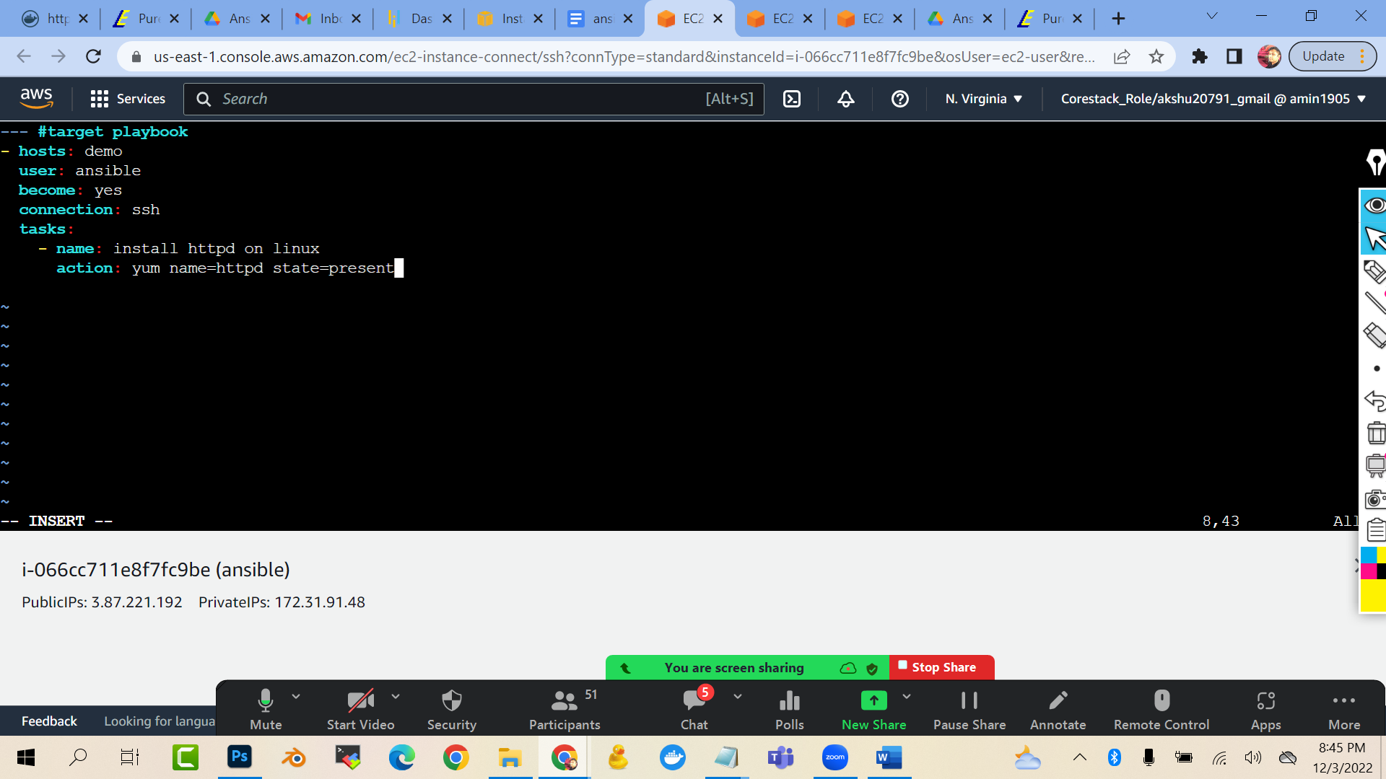

--- #target playbook

- hosts: demo

user: ansible

become: yes

connection: ssh

tasks:

- name: install httpd on linux

action: yum name=httpd state=present

(press esc :wq to exit)

To execute this anisble playbook:

ansible-playbook targetfile.yml